MS SQL SERVER
Standard Operating Procedures
(SOP)
SQL Server job monitoring and purging job history

Submitted to



BY



CIS, Wipro Limited

Document Details
Project Name | Innogy SE
Account | CIS
IT Component/Application Title | SQL Server job monitoring and purging job history
Current Version | 1.5
List of Contributors | Pradipkumar Kansara, Kiran Bhalekar, Ayushi Gautam, Sivakumar Goud, Nanda Kishore Reddy
Customer Contact Information

Version History
(All revisions made to this document must be listed in chronological order. All revisions must be approved. Review and Approval can be done by an internal source or by the customer)
Version | Date of Revision | Description | Author | Reviewed By | Approved By
1.0 | 29-08-2015 | Initial Draft | Kiran Bhalekar | Pradipkumar Kansara | Mahesh Keshatwar
1.1 | 04-09-2015 | Document Completed | Kiran Bhalekar | Pradipkumar Kansara | Mahesh Keshatwar
1.2 | 21-08-2016 | Updated document to standard format | Kiran Bhalekar | Pradipkumar Kansara | Mahesh Keshatwar
1.3 | 17-05-2017 | Wipro and Innogy Logo changed | Sivakumar Goud | Pradipkumar Kansara | Mahesh Keshatwar
1.4 | 12-09-2017 | Updated document to Wipro Standard format with header and footer | Sivakumar Goud | Pradipkumar Kansara | Santosh Badiger
1.5 | 18-12-2018 | Updated the content | Nanda Kishore Reddy | Pradipkumar Kansara | Santosh Badiger

Document Distribution List
S.No | Name and Company | Purpose
1 | RWEIT-SQLDBA | Document is useful for monitoring jobs and Purging history.
2

TABLE OF CONTENT
1. Purpose 4
2. Scope 4
3. Monitoring Jobs 4
3.1 Script to monitor job 4
3.1.1 Script 4
3.1.2 Output 5
4 Monitoring Job using Job Activity Monitor 6
- Purging Job History 7
6 Reference 17

Purpose
This document is prepared for the concept of SQL Server database at <Customer Name>.

Scope
This document is prepared for Wipro sustenance team and provides the concepts of SQL Server database at <Customer name>.

Monitoring Jobs

Script to monitor job

Script
select B.job_id'Job ID',
name'Job Name',
enabled'Enabled',
description'Description',
session_id'Session ID',
date_created'Creation Date',
date_modified'Modification Date',
run_requested_date'Job_last_Execution_Requested_Date_Time',
JobExecutionRequestBy = case when run_requested_source=1 then 'SOURCE_SCHEDULER'
when run_requested_source=2 then 'SOURCE_ALERTER'
when run_requested_source=3 then 'SOURCE_BOOT'
when run_requested_source=4 then 'SOURCE_USER'
when run_requested_source=6 then 'SOURCE_ON_IDLE_SCHEDULE'
END,
Status_of_job_last_execution = case when run_status=0 then 'Failed'
when run_status=1 then 'Succeeded'
when run_status=2 then 'Retry'
when run_status=3 then 'Canceled'
when run_status=4 then 'In progress'
END,
message'Job Execution Message',
sql_severity'Severity of error',
sql_message_id'Error message ID',
start_execution_date 'Job last Execution Start Date Time',
last_executed_step_id 'JobExecution last Stepid',
start_step_id'Next Step ID',
last_executed_step_date 'Job Last Step Execution Start Date Time',
stop_execution_date 'Job Execution Finish Date Time',
next_scheduled_run_date 'Next Scheduled Run Date Time'
from msdb..sysjobactivity A,msdb..sysjobs B,msdb..sysjobhistory C
where A.job_id=B.job_id and B.job_id=C.job_id;

Output
Job ID Job Name Enabled Description Session ID Creation Date Modification Date Job_last_Execution_Requested_Date_Time JobExecutionRequestBy Status_of_job_last_execution Job Execution Message Severity of error Error message ID Job last Execution Start Date Time JobExecution last Stepid Next Step ID Job Last Step Execution Start Date Time Job Execution Finish Date Time Next Scheduled Run Date Time
----------------------- ----------------- ---------------- ------------
2B6ECA0F-5D97-443A-8609-56C89F2A4FF4 main plan 1 No description available. 5 2009-03-25 12:00:52.780 2009-03-25 12:00:56.640 2009-03-25 12:05:00.000 SOURCE_SCHEDULER Succeeded Executed as user: CST-705925\SYSTEM. The package executed successfully. The step succeeded. 0 0 2009-03-25 12:05:00.000 1 1 2009-03-25 12:05:01.000 2009-03-25 12:08:42.000 2009-03-26 12:05:00.000
2B6ECA0F-5D97-443A-8609-56C89F2A4FF4 main plan 1 No description available. 5 2009-03-25 12:00:52.780 2009-03-25 12:00:56.640 2009-03-25 12:05:00.000 SOURCE_SCHEDULER Succeeded The job succeeded. The Job was invoked by Schedule 1 (main plan-Schedule). The last step to run was step 1 (main plan). 0 0 2009-03-25 12:05:00.000 1 1 2009-03-25 12:05:01.000 2009-03-25 12:08:42.000 2009-03-26 12:05:00.000
(2 row(s) affected)

Monitoring Job using Job Activity Monitor
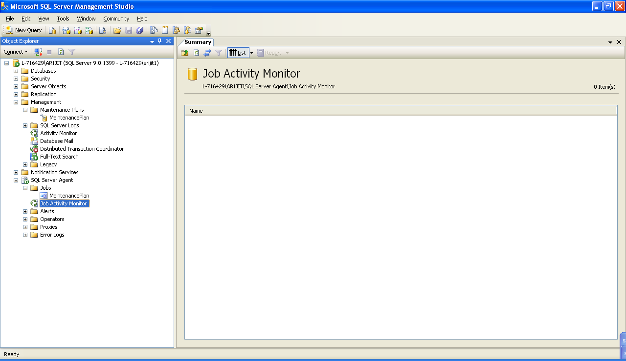
Double Click on SQL Server Agent > Jobs > Job Activity Monitor.
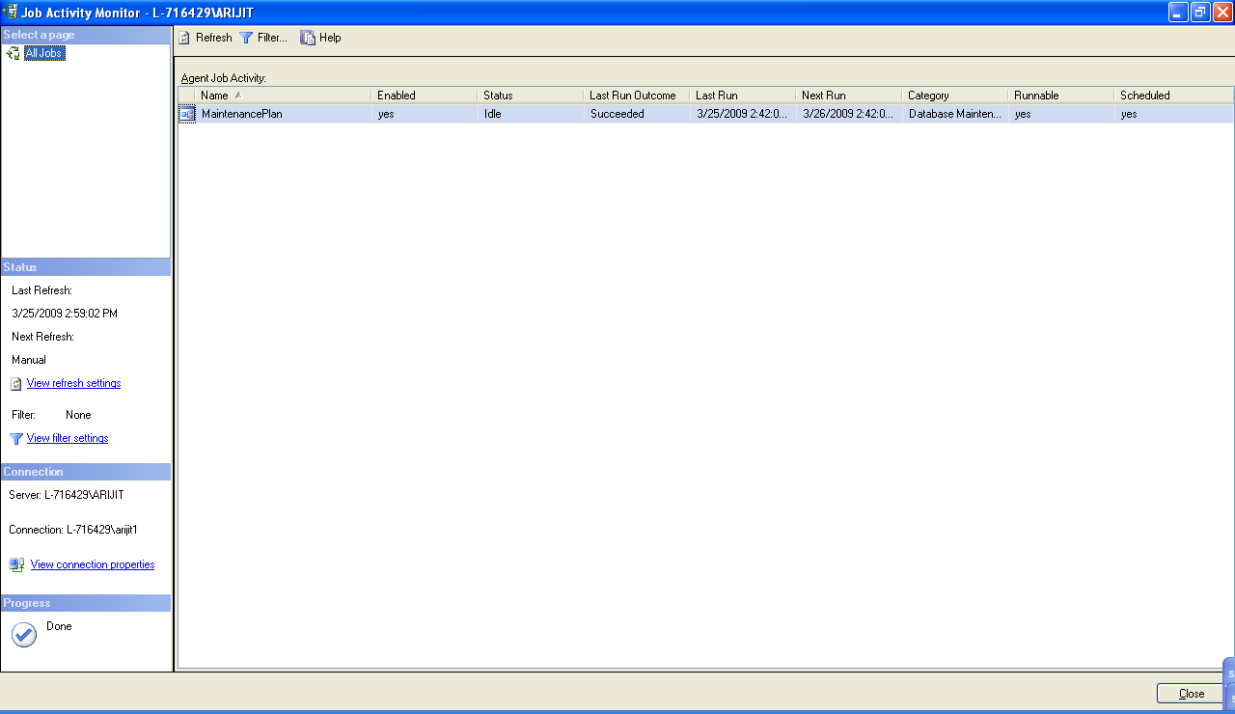

Purging Job History
Job history can be purged using the maintenance plan
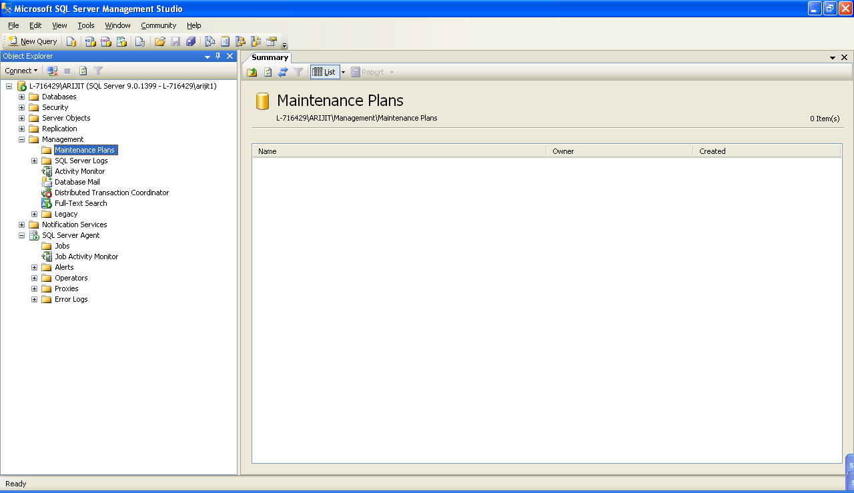
Right Click Maintenance Plans > Maintenance Plan Wizard:
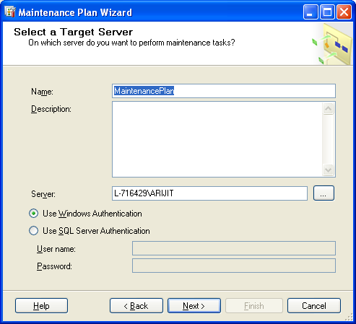
Click Next>
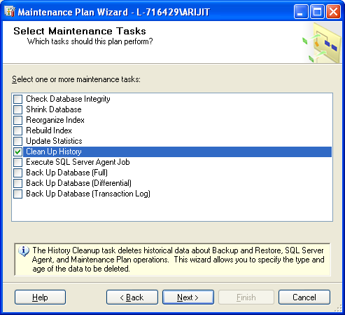
Select Clean Up History
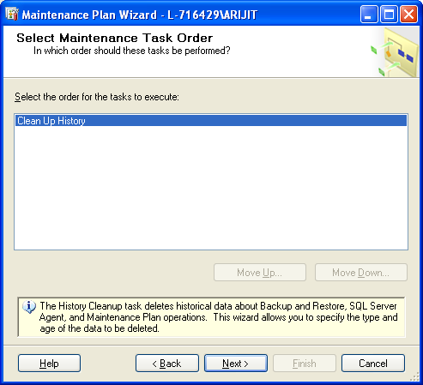
Click Next >
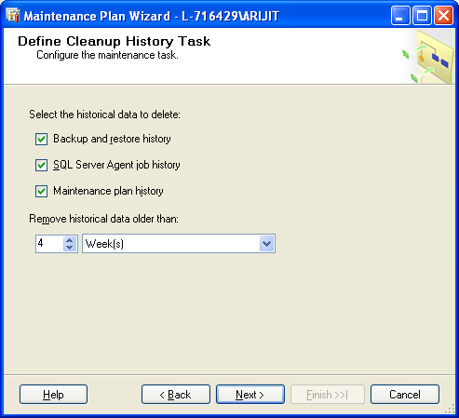
Click Next >
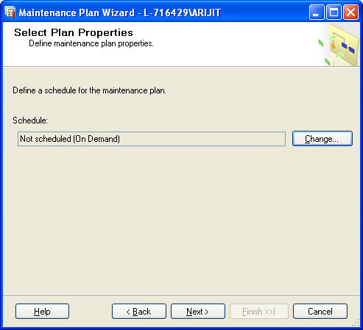
Click Change…
Apply the required settings.
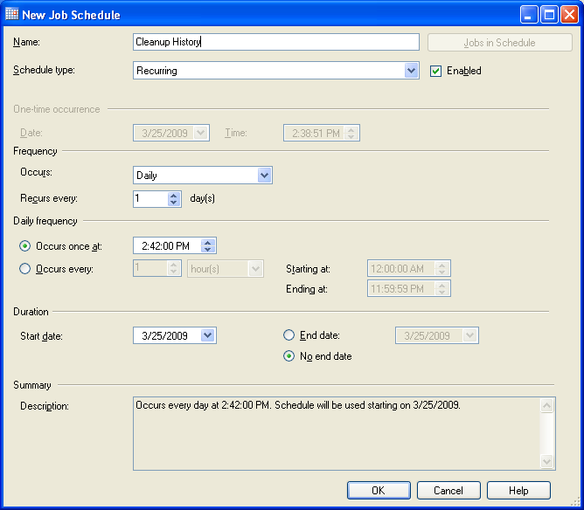
Click OK.
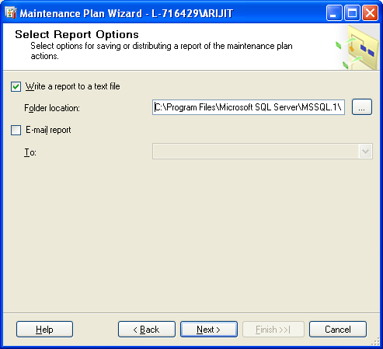
Select the Write a report to a text file option and specify a Folder Location.
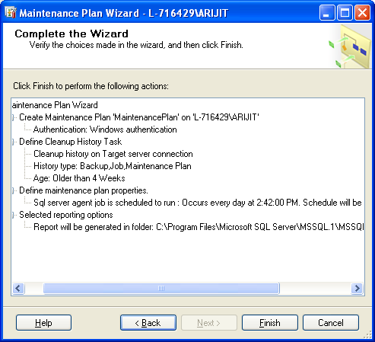
Click Finish.
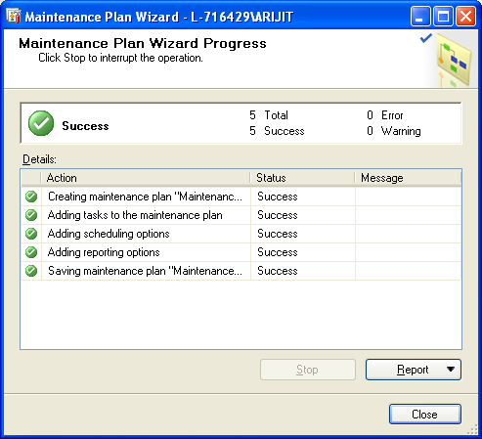
Click Close.
Whenever it is required to purge the old job history, execute the job using the below steps:
In object explorer, Goto Instance Name > SQL Server Agent > Jobs > MaintenancePlan
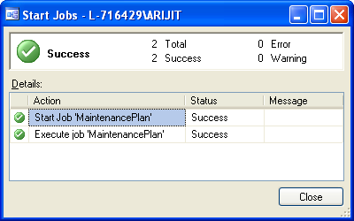

Reference
http://support.microsoft.com/kb/909967

